Simple Shapes
# Source: AI Source: Provided by: [Data Path: Persons Table -> ID Column: 1, Name_En Column: Motasem Essam] -> From: [ChatGPT] on [7/25/2026]
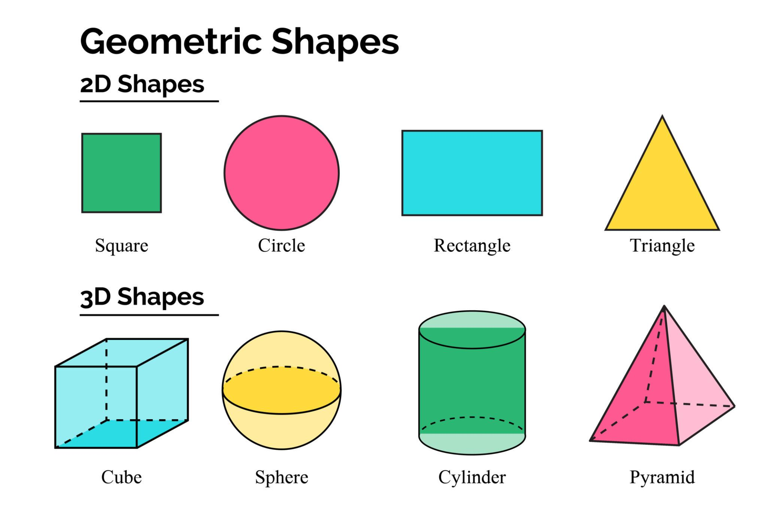
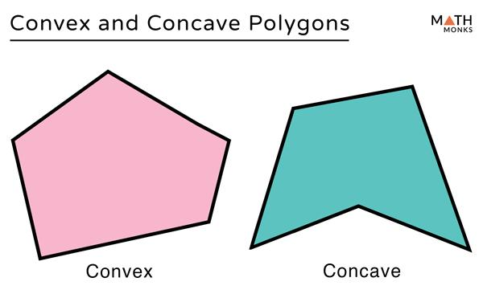
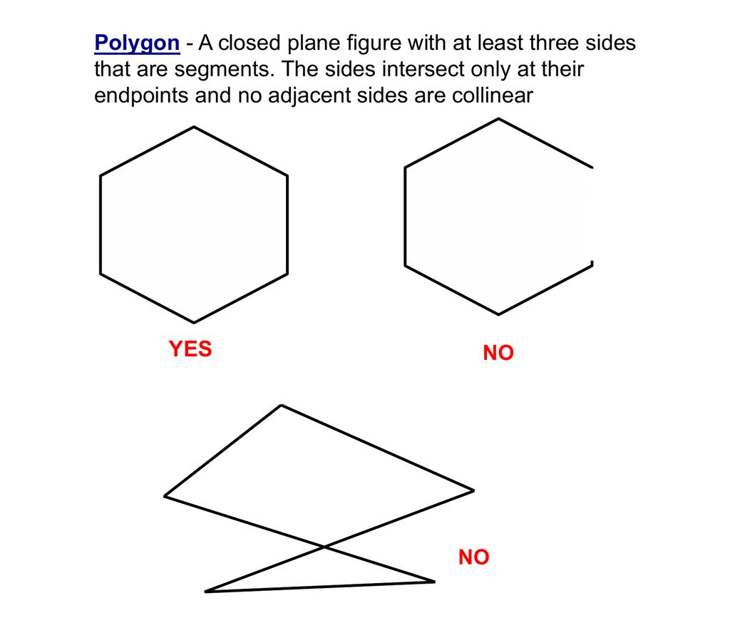
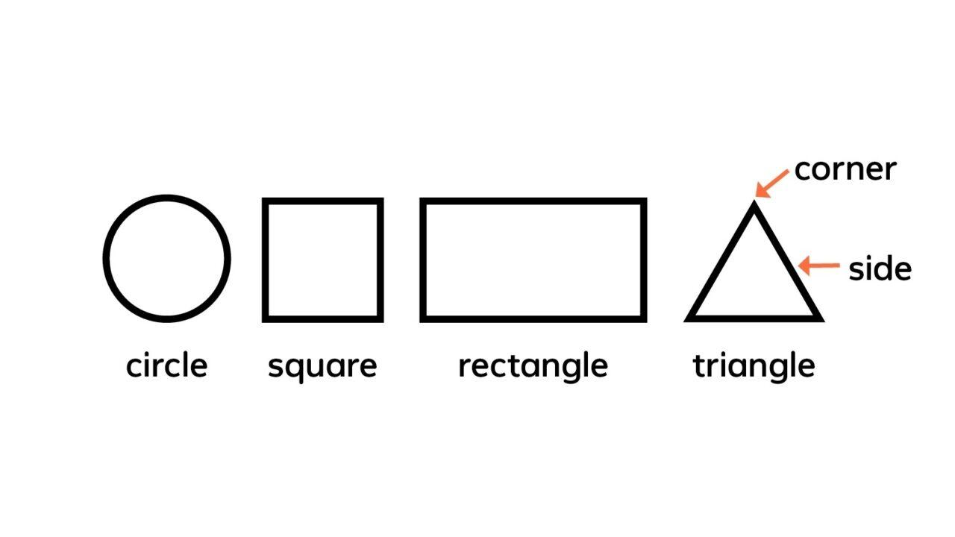
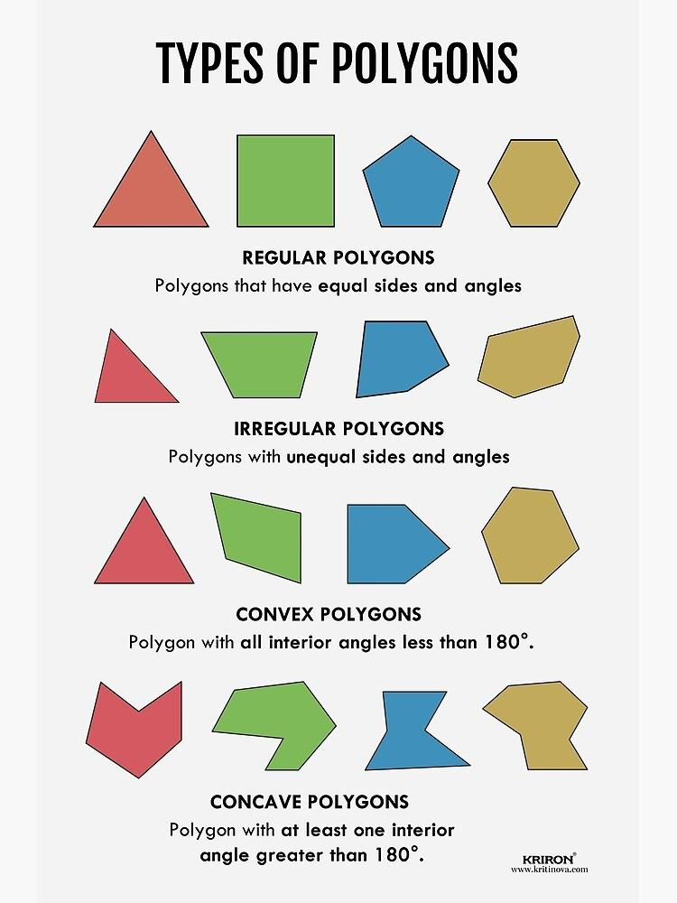

Definition
# Source: AI Source: Provided by: [Data Path: Persons Table -> ID Column: 1, Name_En Column: Motasem Essam] -> From: [ChatGPT] on [7/25/2026]
A Simple Shape is a geometric figure whose boundary does not cross or intersect itself.
For a polygon, a simple polygon is one in which no two non-adjacent sides intersect except at their common endpoints.
$$\boxed{\text{Simple Shape}=\text{Shape with a non-self-intersecting boundary}}$$
The term simple describes the structure of the boundary. It does not mean that the shape must have few sides or be easy to draw.

Fundamental Characteristics
# Source: AI Source: Provided by: [Data Path: Persons Table -> ID Column: 1, Name_En Column: Motasem Essam] -> From: [ChatGPT] on [7/25/2026]
A simple shape generally has:
- A clearly defined boundary
- No self-intersection
- A distinct interior region
- A distinct exterior region
- Vertices and edges when it is a polygon
For a simple polygon:
$$\boxed{\text{Non-adjacent sides do not cross}}$$

Simple Polygon
# Source: AI Source: Provided by: [Data Path: Persons Table -> ID Column: 1, Name_En Column: Motasem Essam] -> From: [ChatGPT] on [7/25/2026]
A Simple Polygon is a polygon whose boundary does not intersect itself.
Examples include:
- Triangle
- Square
- Rectangle
- Pentagon
- Hexagon
- Concave polygon
- Regular polygon
- Irregular polygon
Both convex and concave polygons can be simple.
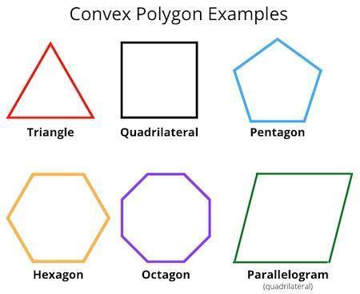
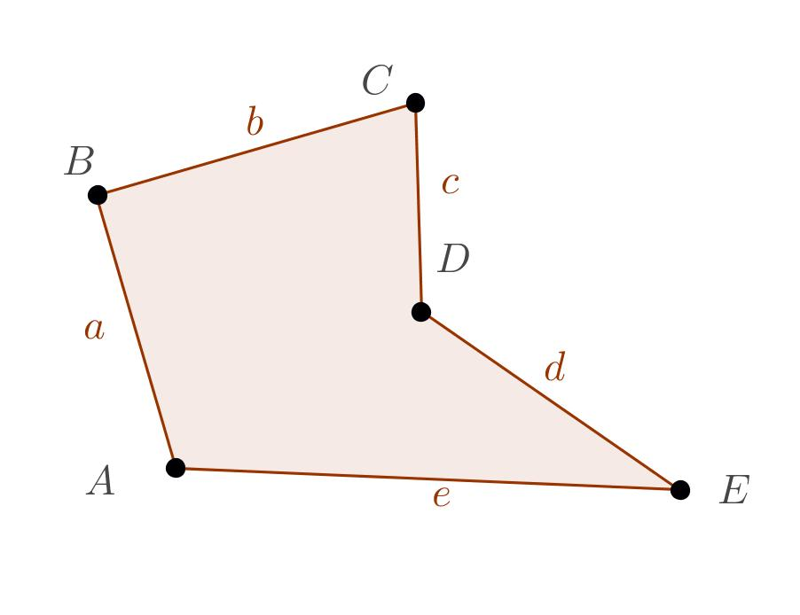
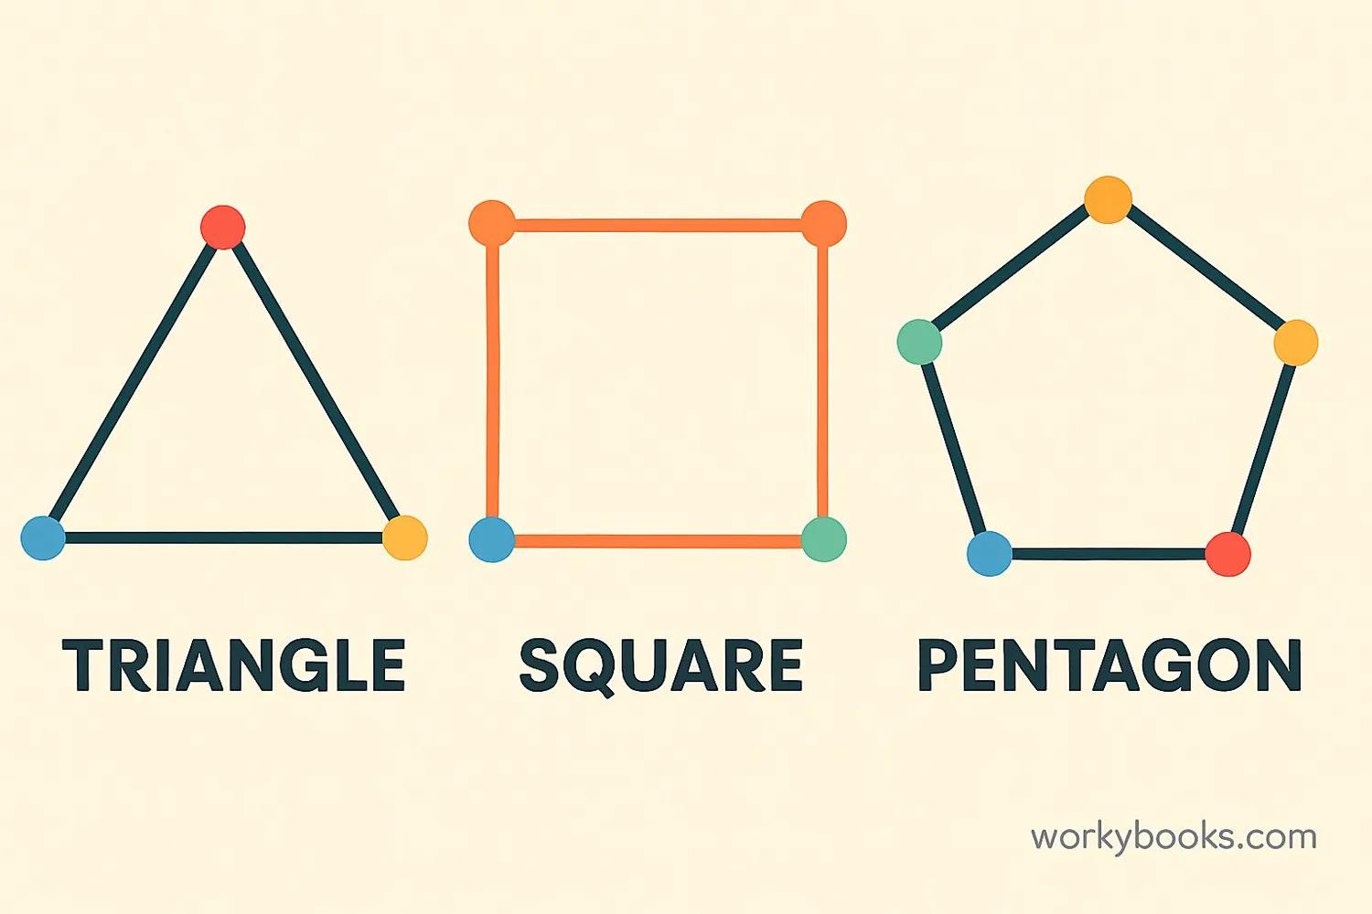
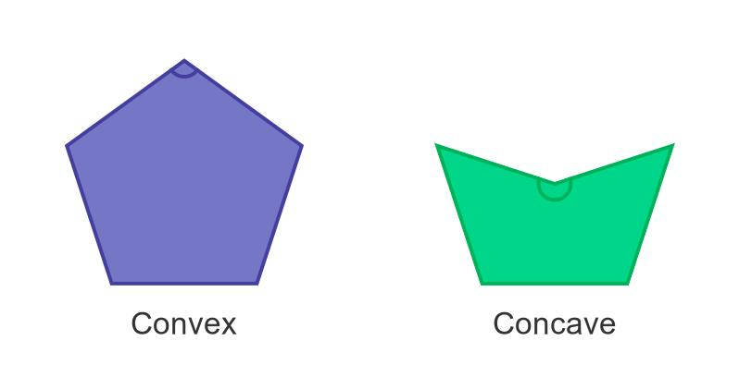
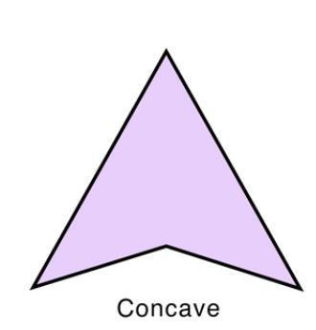

Main Types of Simple Shapes
# Source: AI Source: Provided by: [Data Path: Persons Table -> ID Column: 1, Name_En Column: Motasem Essam] -> From: [ChatGPT] on [7/25/2026]
A useful classification is:
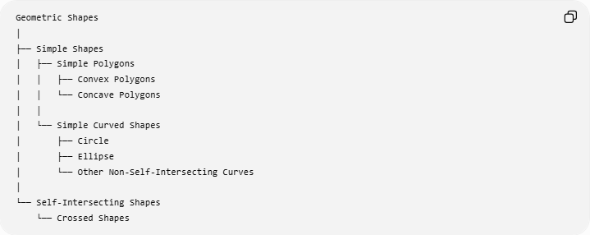
Geometric Shapes
│
├── Simple Shapes
│ ├── Simple Polygons
│ │ ├── Convex Polygons
│ │ └── Concave Polygons
│ │
│ └── Simple Curved Shapes
│ ├── Circle
│ ├── Ellipse
│ └── Other Non-Self-Intersecting Curves
│
└── Self-Intersecting Shapes
└── Crossed Shapes
For polygons:
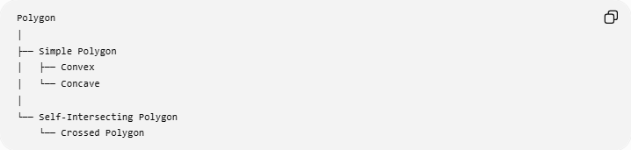
Polygon
│
├── Simple Polygon
│ ├── Convex
│ └── Concave
│
└── Self-Intersecting Polygon
└── Crossed Polygon
This is a particularly useful classification for your geometry knowledge base.

Simple vs. Self-Intersecting
# Source: AI Source: Provided by: [Data Path: Persons Table -> ID Column: 1, Name_En Column: Motasem Essam] -> From: [ChatGPT] on [7/25/2026]
Simple Shape
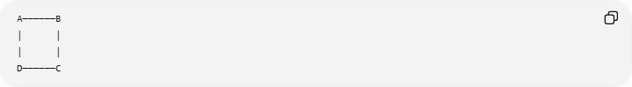
A──────B
│ │
│ │
D──────C
The boundary does not cross itself.
Self-Intersecting Shape
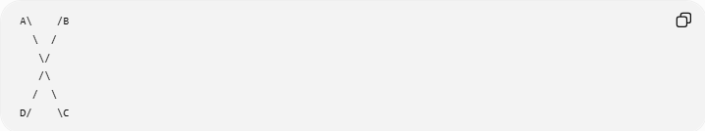
A\ /B
\ /
\/
/\
/ \
D/ \C
The boundary crosses itself.
Therefore:
$$\boxed{\text{Simple Shape}≠\text{Crossed Shape}}$$

Simple Convex Shape
# Source: AI Source: Provided by: [Data Path: Persons Table -> ID Column: 1, Name_En Column: Motasem Essam] -> From: [ChatGPT] on [7/25/2026]
A simple convex polygon has no self-intersection and no indentation.
Every interior angle is less than ${180}^{∘}$:
$$\boxed{0^{∘}<θ<{180}^{∘}}$$
Examples:
- Triangle
- Square
- Rectangle
- Regular pentagon

Simple Concave Shape
# Source: AI Source: Provided by: [Data Path: Persons Table -> ID Column: 1, Name_En Column: Motasem Essam] -> From: [ChatGPT] on [7/25/2026]
A simple concave polygon also has no self-intersection, but it has at least one indentation.
At least one interior angle is greater than ${180}^{∘}$:
$$\boxed{{180}^{∘}<θ<{360}^{∘}}$$
For example, a dart-shaped quadrilateral can be simple and concave.
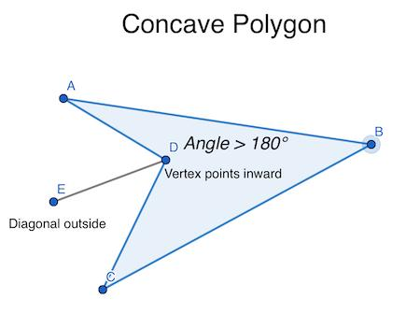
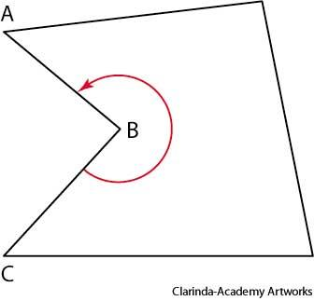
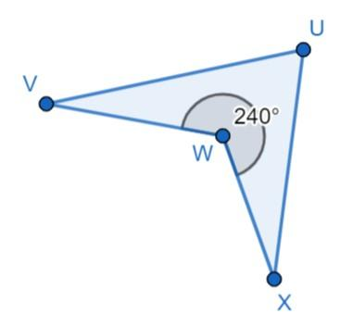
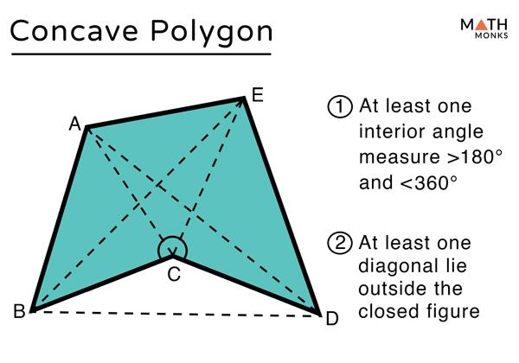

Interior and Exterior
# Source: AI Source: Provided by: [Data Path: Persons Table -> ID Column: 1, Name_En Column: Motasem Essam] -> From: [ChatGPT] on [7/25/2026]
One important property of a simple closed shape is that it separates the plane into:
- An interior
- An exterior
This is formally related to the Jordan curve theorem for simple closed curves.
For elementary geometry, the important idea is:
$$\boxed{\text{Simple closed boundary}→\text{Clearly defined inside and outside}}$$

Area
# Source: AI Source: Provided by: [Data Path: Persons Table -> ID Column: 1, Name_En Column: Motasem Essam] -> From: [ChatGPT] on [7/25/2026]
Because a simple closed shape has a well-defined interior, its geometric area is well-defined.
For a simple polygon, several methods can be used, depending on the shape:
- Standard area formulas
- Decomposition into triangles
- Coordinate geometry
- Shoelace formula
For vertices
$$\left(x_{1} , y_{1}\right),…,\left(x_{n} , y_{n}\right)$$
the shoelace formula can be used:
$$\boxed{A=\frac{1}{2}∣\sum_{i=1}^{n}{x_{i}}y_{i+1}-\sum_{i=1}^{n}{y_{i}}x_{i+1}∣}$$
with the indices taken cyclically.

Perimeter
# Source: AI Source: Provided by: [Data Path: Persons Table -> ID Column: 1, Name_En Column: Motasem Essam] -> From: [ChatGPT] on [7/25/2026]
For a simple polygon with side lengths
$$s_{1},s_{2},…,s_{n}$$
the perimeter is:
$$\boxed{P=s_{1}+s_{2}+⋯+s_{n}}$$

Example
# Source: AI Source: Provided by: [Data Path: Persons Table -> ID Column: 1, Name_En Column: Motasem Essam] -> From: [ChatGPT] on [7/25/2026]
Consider a rectangle with:
$$l=8\text{ cm}$$
and
$$w=5\text{ cm}$$
The rectangle is a simple polygon because none of its sides self-intersect.
Perimeter
$$P=2\left(l+w\right) \\ P=2\left(8+5\right)=26\text{ cm}$$
Area
$$A=lw \\ A=8×5=40{\text{ cm}}^{2}$$

Relationship with Crossed Shapes
# Source: AI Source: Provided by: [Data Path: Persons Table -> ID Column: 1, Name_En Column: Motasem Essam] -> From: [ChatGPT] on [7/25/2026]
The most important distinction is:
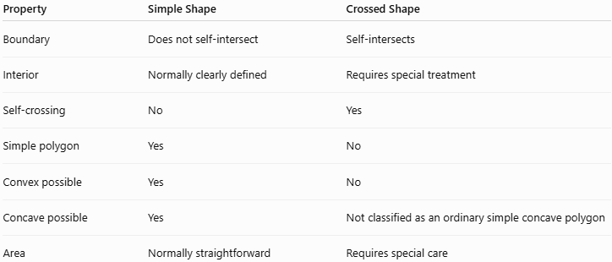
Property | Simple Shape | Crossed Shape
Boundary | Does not self-intersect | Self-intersects
Interior | Normally clearly defined | Requires special treatment
Self-crossing | No | Yes
Simple polygon | Yes | No
Convex possible | Yes | No
Concave possible | Yes | Not classified as an ordinary simple concave polygon
Area | Normally straightforward | Requires special care

Important Terminology
# Source: AI Source: Provided by: [Data Path: Persons Table -> ID Column: 1, Name_En Column: Motasem Essam] -> From: [ChatGPT] on [7/25/2026]
Simple does not mean convex.
A shape can be:
$$\boxed{\text{Simple + Convex}}$$
or:
$$\boxed{\text{Simple + Concave}}$$
For example:
- Rectangle → simple + convex
- Square → simple + convex
- Dart → simple + concave
- Crossed quadrilateral → self-intersecting, therefore not a simple quadrilateral

Real-World Applications
# Source: AI Source: Provided by: [Data Path: Persons Table -> ID Column: 1, Name_En Column: Motasem Essam] -> From: [ChatGPT] on [7/25/2026]
Simple shapes are fundamental in:
- Architecture
- Engineering
- Technical drawing
- Computer graphics
- CAD
- Geographic mapping
- Construction
- Manufacturing
- Mathematics education
- Pattern design

Key Points
# Source: AI Source: Provided by: [Data Path: Persons Table -> ID Column: 1, Name_En Column: Motasem Essam] -> From: [ChatGPT] on [7/25/2026]
- A Simple Shape has a boundary that does not self-intersect.
- A Simple Polygon has no crossing non-adjacent sides.
- Simple polygons can be convex or concave.
- A simple closed shape has a well-defined interior and exterior.
- Its area can normally be calculated using standard geometric methods.
- A Crossed Shape is the opposite structural category because its boundary self-intersects.

Conclusion
# Source: AI Source: Provided by: [Data Path: Persons Table -> ID Column: 1, Name_En Column: Motasem Essam] -> From: [ChatGPT] on [7/25/2026]
Simple Shapes are geometric figures whose boundaries do not cross themselves. For your taxonomy, the clearest structure is:
$$\boxed{\text{Geometric Shapes}→\left\{\begin{matrix}\text{Simple Shapes} \\ \text{Self-Intersecting Shapes}\end{matrix}\right.}$$
For polygons:
$$\boxed{\text{Polygon}→\left\{\begin{matrix}\text{Simple Polygon} \\ \text{Self-Intersecting Polygon}\end{matrix}\right.}$$
Then a Simple Polygon can be divided into Convex and Concave polygons.

